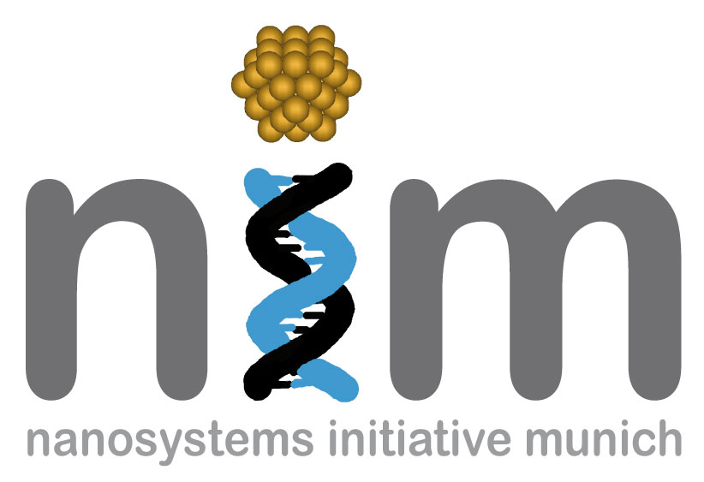


SEMINARANKÜNDIGUNG

Dienstag, 02. Februar 2010
17:15 Uhr

WSI, Seminarraum S 101
„Gradient force transduction and
self-oscillation of nanomechanical resonators„
Nanomechanical systems (NEMS) are freely suspended nanostructures which are driven to vibrate thermally or by means of external actuation. The physical properties of these tiny oscillators differ fundamentally from macroscopic mechanical objects: Nanomechanical resonators are highly sensitive to changes in their environment, and coupling to external degrees of freedom can give rise to strong back-action effects.
In the past years high stress silicon nitride has received considerable interest as a low dissipation material for nanomechanical systems. The large quality factors observed can be retained if non-dissipative transduction schemes are employed. On-chip actuation and readout can be performed by dielectric transduction, taking advantage of electrically induced gradient forces. This universal actuation scheme is broadband, efficient, scalable and suitable for high Q NEMS.
Similarly, optical gradient forces can be employed to drive an evanescently coupled nanoresonator. Purely dispersive coupling is observed for a hybrid system consisting of a silicon nitride resonator and a silica microtoroid cavity. This allows to enter the field of cavity nano-optomechanics. Dynamical back-action mediated by the optical dipole force is observed, while quantum-limited displacement sensitivity is achieved.
Dr. Eva Maria Weig
Center for NanoScience & Fakultät für Physik,
Ludwig-Maximilians-Universität München

