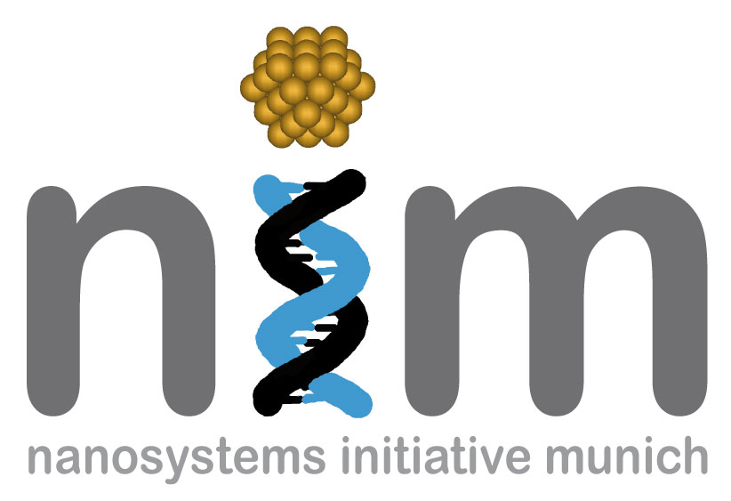


SONDERSEMINAR

Freitag, 23. Januar 2009
13:00 Uhr

WSI, Seminarraum S 101
„Ultrafast, nonlinear, and quantum nanoplasmonics„

This talk introduces and reviews new ideas and recent progress in ultrafast, nonlinear, and quantum nanoplasmonics. It includes a brief Introduction to the topic and forefront, focus areas based partially on original contributions. A nanoscale quantum generator of surface-plasmon fields, SPASER, is of the focus points. We concentrate on dynamic, controllable, ultrafast localization of optical energy on the nanoscale. These localization processes cause variety of enhanced and localized nonlinear phenomena on the nanoscale, in particular, the nonlinear photoelectron emission coherently controlled by the phases of the ultrashort excitation pulses and spatio-temporal coherent control. We discuss extreme nanoplasmonics where phenomena develop on the spatial scale of a few nanometers and temporal scale of hundreds attoseconds. This includes the recently introduced idea of the attosecond nanoplasmonic field microscope. We present both theory and available experimental data, and discuss various applications of nanoplasmonics.

Prof. Mark I. Stockman
Department of Physics and Astronomy,
Georgia State University,
Atlanta, Georgia, USA

