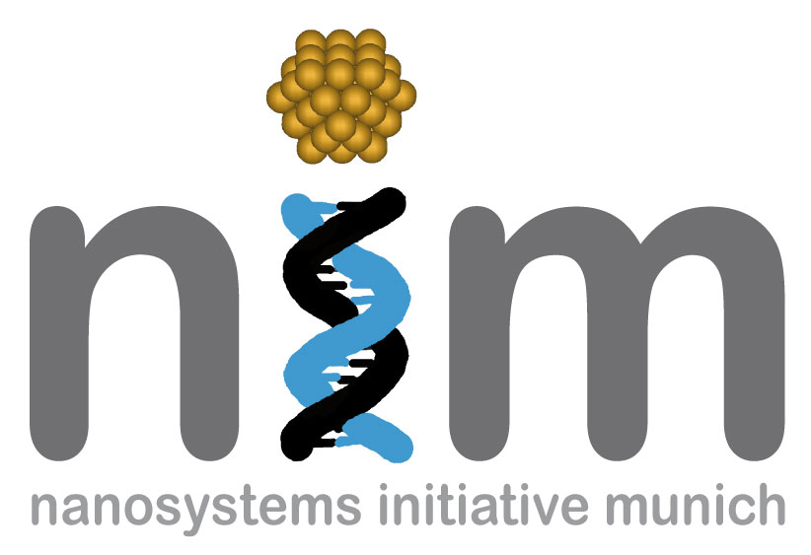


SEMINARANKÜNDIGUNG

Dienstag, 20. April 2010
17:15 Uhr

WSI, Seminarraum S 101
„Nanoscale electro-thermal energy conversion devices and measurements„

Energy consumption in our society is increasing rapidly. A significant fraction of the energy is lost in the form of heat. In this talk we introduce solid-state thermionic/ thermoelectric devices that allow direct conversion of heat into electricity. Novel metal-semiconductor nanocomposites are developed where the heat and charge transport are modified at the atomic level. Theory and experiment are compared for the case of rare-earth semimetal nanoparticles in a semiconductor matrix as well as in nitride metal/semiconductor multilayer films. High thermoelectric figure-of-merit >1 is achieved. Potential to reach energy conversion efficiencies exceeding 20% is discussed. We also describe how similar principles can be used to make micro refrigerators on a chip with cooling power densities exceeding 500W/cm₂. Thermoreflectance imaging is used to measure the transient temperature distribution in the microcoolers with 100ns time and submicron spatial resolution. Picosecond acoustics is also used to study phonon minibands and their effect on the material's thermal properties. Finally, we give an overview of the fundamental coupling between charge and energy transport in materials and the role of the thermoelectric figure-of-merit in microscopic transport.

Prof. Ali Shakouri
Baskin School of Engineering,
University of California Santa Cruz, USA

