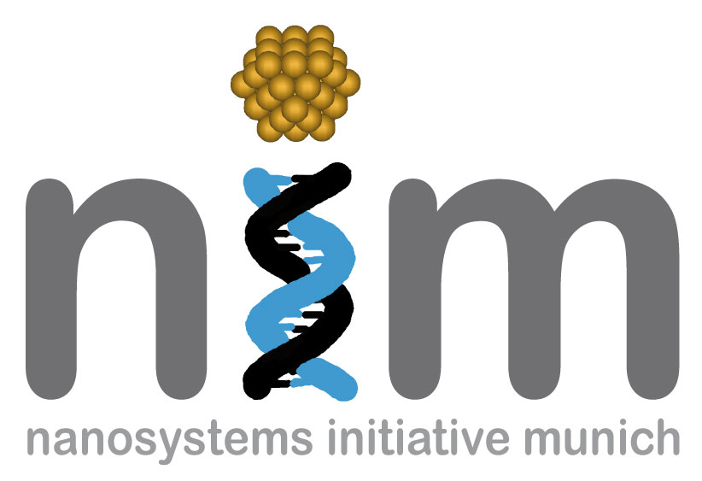


SEMINARANKÜNDIGUNG

Dienstag, 15. Juni 2010
17:15 Uhr

WSI, Seminarraum S 101
„Rapid surface enhanced Raman scattering (SERS) diagnostic assays”

Rapid and accurate detection is an important facet in controlling the spread of disease. Current methods for detection tend to be expensive and often lack sensitivity as well portability. Recent advances in the field of surface enhanced Raman spectroscopy (SERS) have demonstrated the utility of this technology in diverse disciplines ranging from document security to forensics and the development of protein/nucleic acid sensor technologies. Our long-term goal is to develop a SERS based diagnostic tool for pathogens that can be easily adapted for cost effective, portable and compact Raman spectroscopy in a point-of-care facility or field setting.
In this work, indirect and direct capture assays using colloidal Au nanoparticles are being developed for SERS spectroscopy detection of viral DNA and viral immunoassays. The DNA sequence targeted was derived from the West Nile Virus (WNV) RNA genome and selected on the basis of exhibiting minimal secondary structure formation. For the indirect assay, upon incubation with colloidal Au, hybridization complexes containing the WNV target sequence, a complementary capture oligonucleotide conjugated to a strong tethering group and a complementary reporter oligonucleotide conjugated to methylene blue (MB), a Raman label, anchors the resultant ternary complex to Au nanoparticles and positions MB within the required distance for SERS enhancement. In the direct capture scheme, two different capture oligonucleotides are conjugated to both magnetic nanoparticles and gold reporter nanoparticles. The hybridization complex can then be separated and concentrated via magnetism to achieve sensitive detection.

Prof. Patrick Johnson
University of Wyoming, USA

