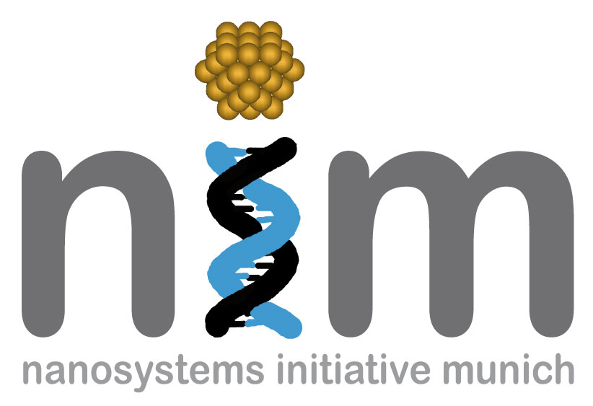


SEMINARANKÜNDIGUNG

Dienstag, 15. Dezember 2009
17:15 Uhr

WSI, Seminarraum S 101

„Chemistry for nanopore analytics„

In nanopores analytics, individual molecules pass through a nanopore to cause detectable changes in pore conductance. In my presentation, I will show how chemistry can be applied to enhance this attractive analytical approach. Examples include the derivatization of DNA to facilitate the sensing of individual bases, and the tailored surface modification for solid-state nanopores to avoid non-specific interactions and achieve specific recognition of analytes.

Dr. Stefan Howorka
University College London,
United Kingdom

