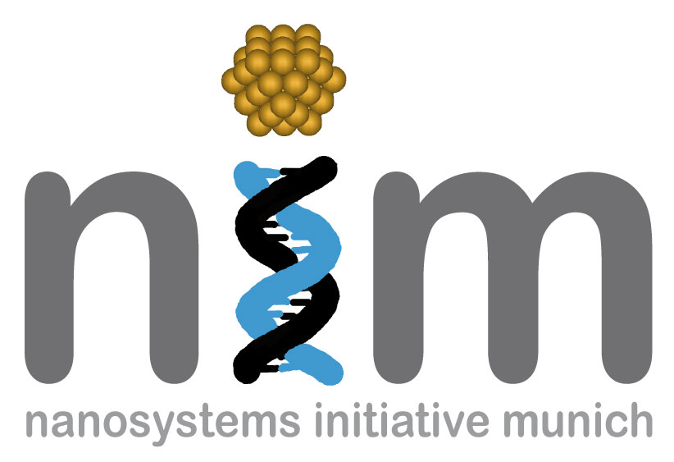


SONDERSEMINAR

Freitag, 02. Juli 2010
12:00 Uhr

WSI, Seminarraum Container
„Microsphere resonator arrays for photonics and biomedical optics applications”

Dielectric microspheres, with sizes on the order of several wavelengths, support high-quality whispering gallery (WG) modes and focus light into tiny spots termed nanoscale photonic jets. In this talk, we review properties of chains and arrays of microspheres integrated on the same chip or assembled inside hollow waveguides. The resonant optical properties of such systems can be engineered on the basis of tight-binding WG modes in photonic atoms that allow developing coupled arrays of microlasers, delay lines, and sensors. In practical structures the resonant optical properties are, however, strongly influenced by disorder effects. The light focusing effects in such structures are determined by the properties of non-resonant nanojet-induced modes. These structures allow compact focusing of multimodal beams delivered by flexible waveguides used in laser-tissue surgery and other applications.

Prof. Vasily Astratov
UNC Charlotte, USA

